Loan Origination Copilot Workflow Chart
  - Standalone workflow reference with labelled decision points, tool interactions, and example journey
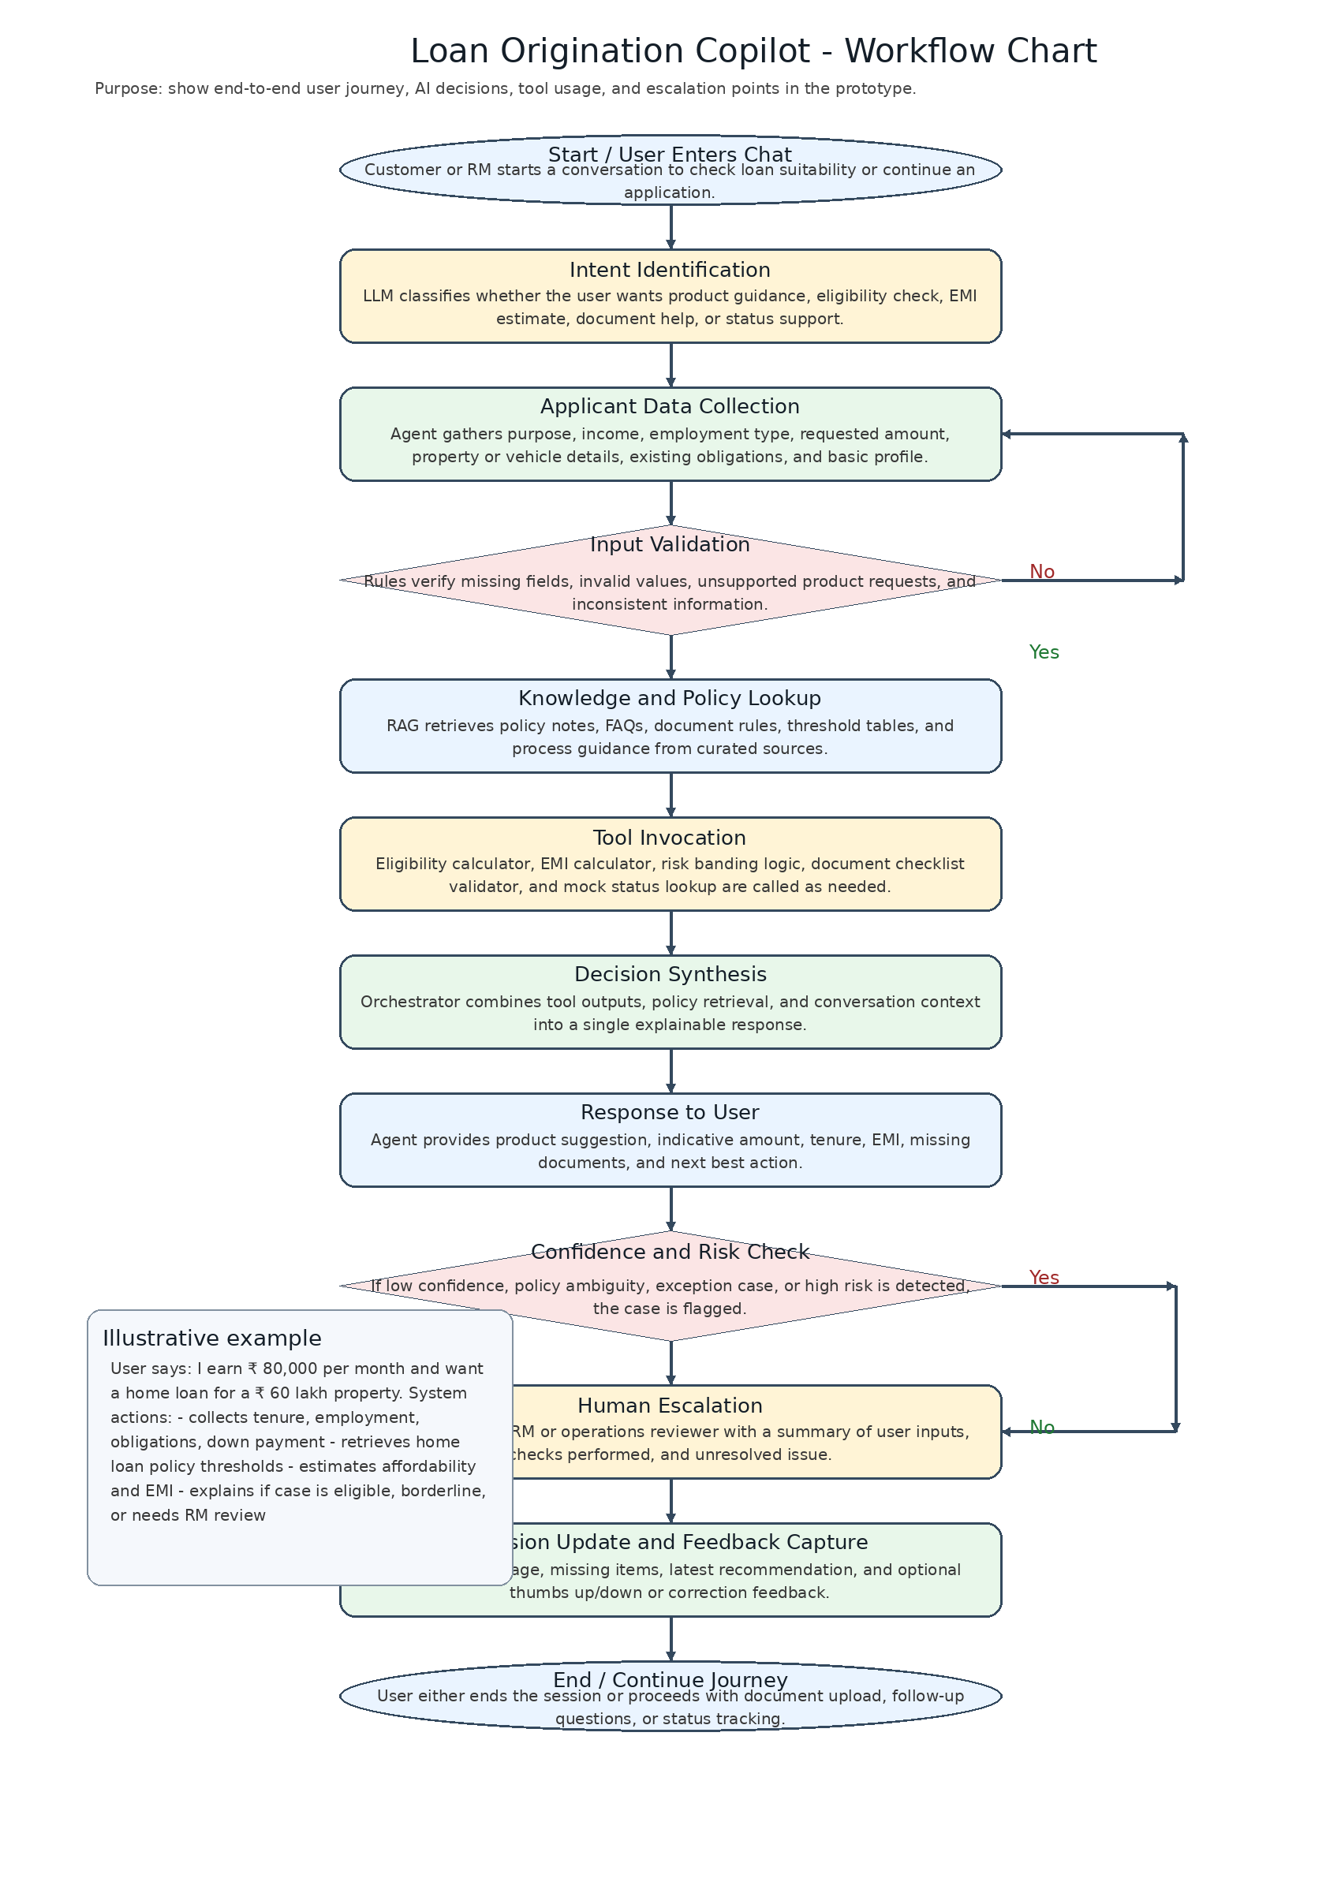

1. Workflow intent
This workflow shows how a customer or RM moves through the copilot from the first message to recommendation, escalation, or continuation of the application journey. It highlights where the LLM reasons conversationally, where deterministic checks occur, and where the system must defer to a human.

2. Label explanation
Label | Meaning
Intent Identification | Classifies the user request into a manageable next action such as eligibility check, product guidance, EMI estimate, document help, or status query.
Input Validation | Prevents the system from proceeding with missing or contradictory information.
Knowledge and Policy Lookup | Uses retrieval to ground answers in curated documents rather than generic model output.
Tool Invocation | Calls deterministic functions for calculations and rules.
Confidence and Risk Check | Prevents overconfident answers in unclear, policy-sensitive, or borderline cases.
Human Escalation | Routes the case to RM or operations when the prototype should stop automated handling.

3. Example walkthrough
- A user asks for a home loan and shares salary, requested property value, and current obligations.
- The agent collects missing details such as down payment and employment type.
- The system validates that the key fields are present and queries the knowledge base for applicable home-loan rules.
- The eligibility and EMI tools generate indicative outputs.
- The system then explains the product recommendation, expected affordability range, missing documents, and whether RM follow-up is required.

